**Project 1**

**A study on the Causes of Road Accidents in UK**

**Group - 1**

Members: Patrick Yau, Sami Bsata & Sharanjit Singh

**A study on the Causes of Road Accidents in UK**

Driving is a fact of life for many Canadians, with the average Canadian driving about 50 km a day1. Studying road accidents is important as it allow us to understand their causes and develop policies and road safety measures to reduce accidents, especially those lead to bodily injuries.

Our group intend to unfold the possible cause of accidents using UK data from 2021 to 20222 by examining the below factors.

* Weather condition (Fine no high winds, Fine + high winds, Fog or mist, Raining + high winds, raining no high winds, Snowing + high winds, Snowing no high winds, other)
* Road condition (Dry, Wet or damp, Frost or ice, Snow, Flood over 3cm deep)
* Lighting condition (Daylight, Darkness – lights lit, Darkness – no lighting, Darkness – lighting unknown, Darkness – lights unlit)
* Urban or Rural area
* Road type (Dual carriageway, one way street, Roundabout, Single carriageway, Slip Road)
* Accident severity (Slight “Minor”, Serious, Fatal)

**Before the study, our group hypothesized that:**

* Poor weather conditions, such as snow, rain and fog will lead to an increase in the number and severity of accidents.
* Urban areas will generally have a higher number of accidents compared to rural areas
* Single-carriageway roads, where vehicles travel in opposite direction without a median, will have a higher incidence of casualties compared to multi-carriageway roads
* Poor lighting conditions, such as nighttime and unlit roads, will lead to a higher number of accidents
* Poor road conditions, where the surface is covered with ice or snow, will lead to an increase in the number of accidents
* Minor (slight severity) accidents occur more frequently then serious or fatal accidents.

**Summary of findings:**

Having set our expectation, our group began analyzing the data.

* **Accidents by month over period of 2021 and 2022**

**Year 2021:** Overall, we see accidents mostly happen during month of November and lowest in February.

**Year 2022:** Overall, we see accidents mostly happen during month of November and lowest in December.

In addition, there is an upward trend from February to November, then in December, accidents tend to decrease, as seen on our line graph.

1. **Poor weather leads to more accidents and severity of accidents - Result “False”**

When comparing weather condition to the severity of the accidents, to our surprise, we found that most accidents occur in almost perfect weather.

1. **Urban areas have more accidents than rural areas** - **Result “True”**

As expected, accidents occur more in urban areas compared to rural areas due to their congested nature.

1. **More casualties happen on single carriageway road** - **Result “True”**

Our finding also confirmed that single-carriageway roads, where there is no median between traffic traveling in opposite direction, have more casualties than other types of road types.

1. **Poor lighting leads to more accidents - Result “False”**

.

1. **Poor road condition leads to more accidents – Result “False”**

Our data also revealed that most accidents happen on dry road, as opposed to the icy or snowy road surface we were expecting.

1. **Light severity accidents happen more – Result “True”**

Finally, our data confirm that minor accidents happen the most, compare to serious and fatal accidents.

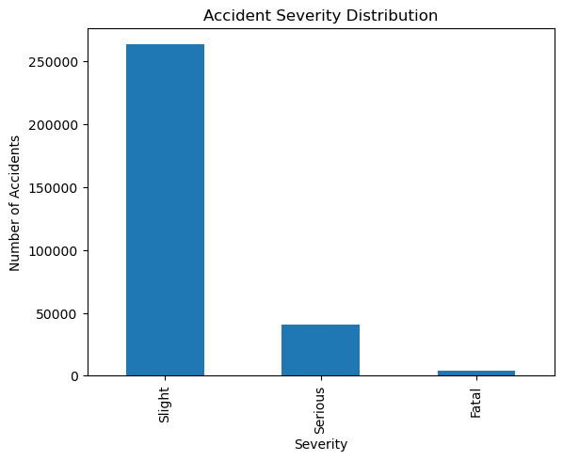

**Conclusion:**

Most accidents happen in good weather, with good lighting and good road conditions, and on single-carriageway road where there is no median to protect traffic traveling in opposite direction.

Accidents happen most in urban areas where drivers have more to look out for, such as traffic signs and signals, surrounding vehicles, pedestrians and cyclists.

These findings lead us to think that there can be other possible factors like driver distraction may be possible cause of accidents which is not present in the given data and needs to be reviewed and limitation of our studied data set.

**References:**

* <https://natural-resources.canada.ca/energy-efficiency/transportation-energy-efficiency/personal-vehicles/autosmart-driver-training>

* <https://www.kaggle.com/datasets/xavierberge/road-accident-dataset>
* https://chatgpt.com